Al sensei:

Please paste screenshots here and write justifications of each core elements

Maybe like put numbers for elements on the screenshots and write one or two sentences for each one.

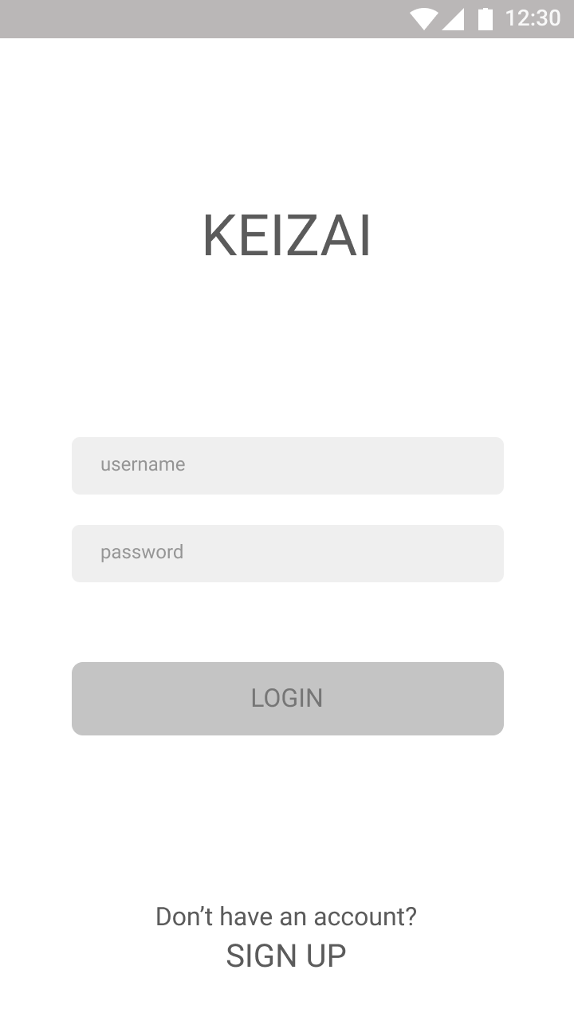

For the first screen, users (language learners) need to login to the app with their username and password

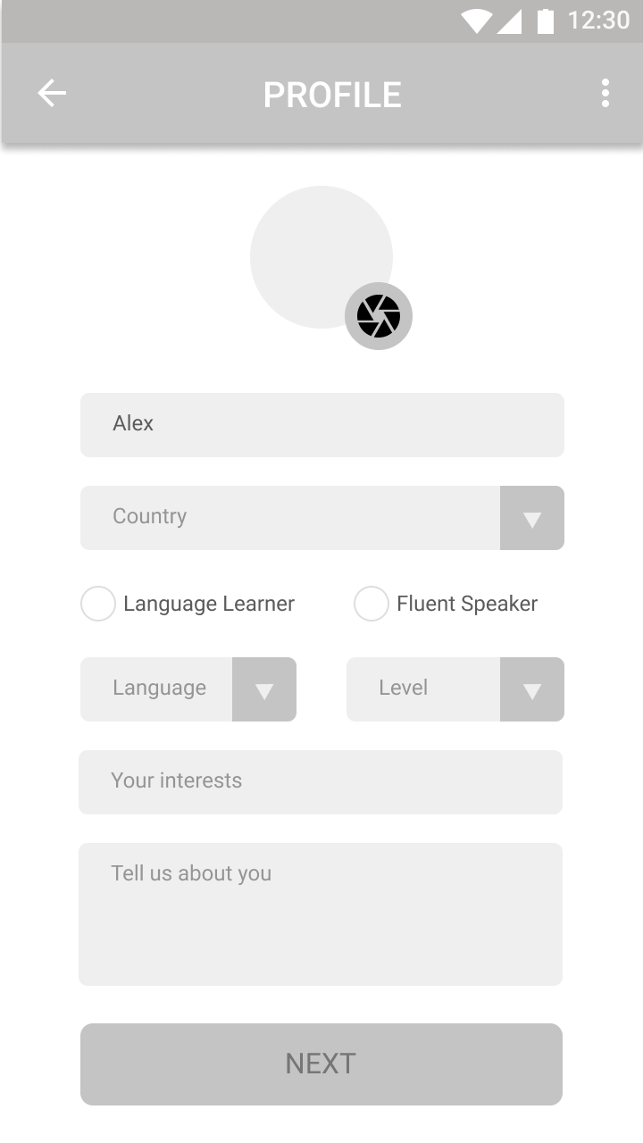

After they login, there will be a profile page for them to fill. It contains picture, name, nationality, their user status (learner or fluent), the language that they want to learn, how they put their self in a level or grade on that language, with a list of interest that they interested in, and lastly a short description about them.

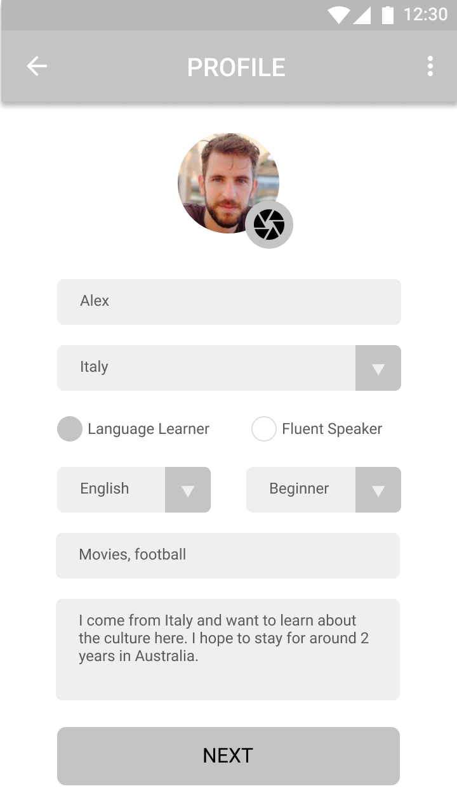

Here is the example of how the filled profile look like when it’s complete.

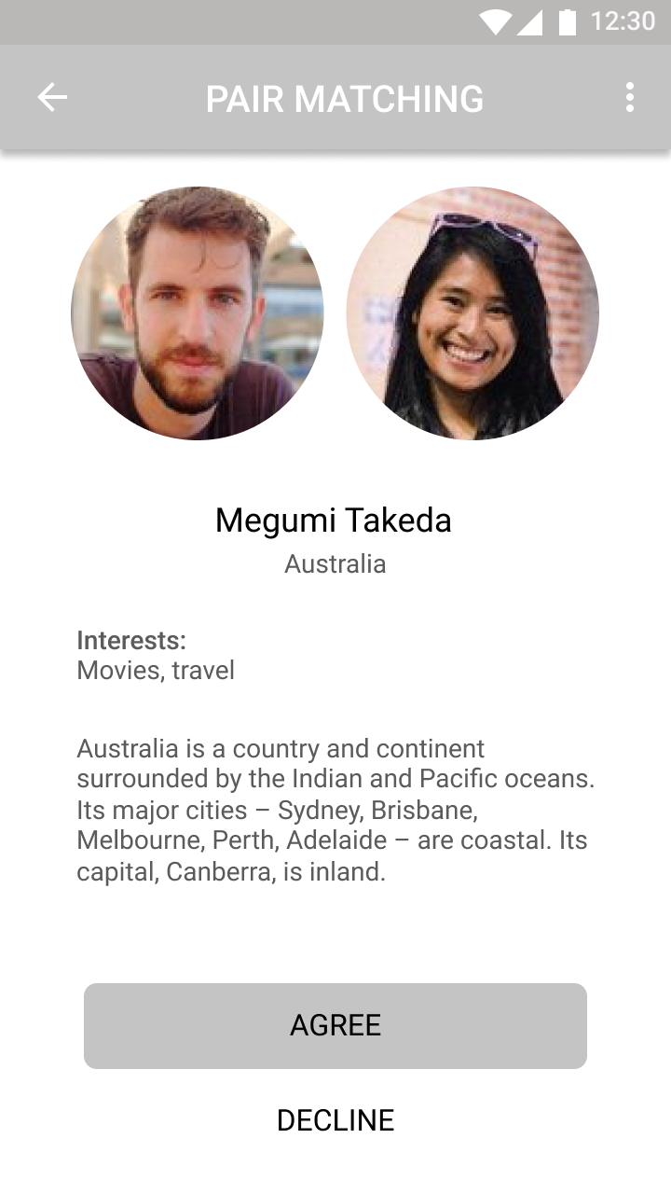

After finishing the profile, users gonna see their conversation partner that suggested by the system based on their interest, language skill, and location. On this part, users can accept the learning partner or decline it.

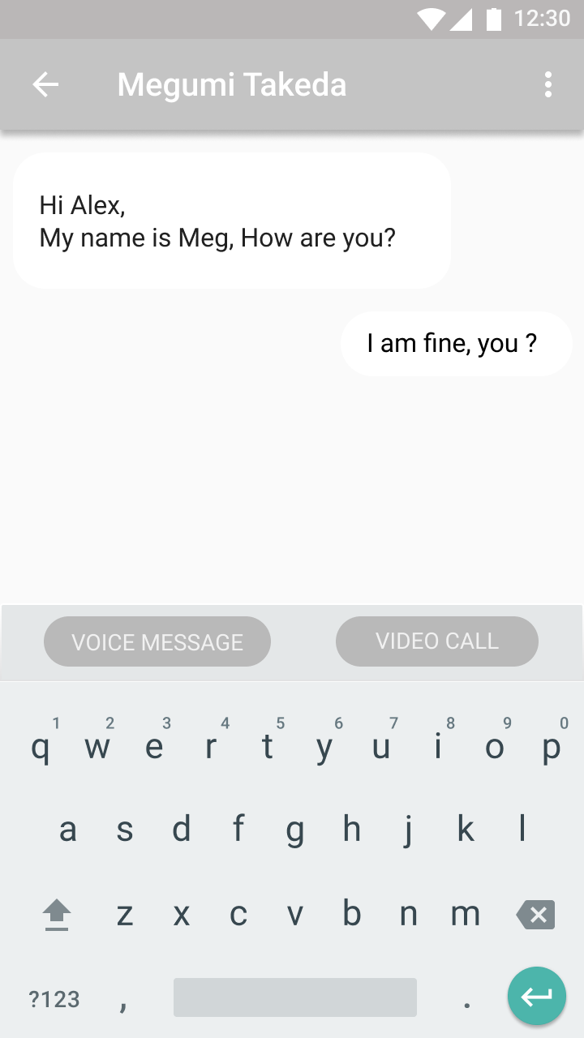

There are 3 learning feature that users can chose, namely, text message, voice message, and video call. This is the text message screen where learners can chating with the fluent speaker to learn the language.

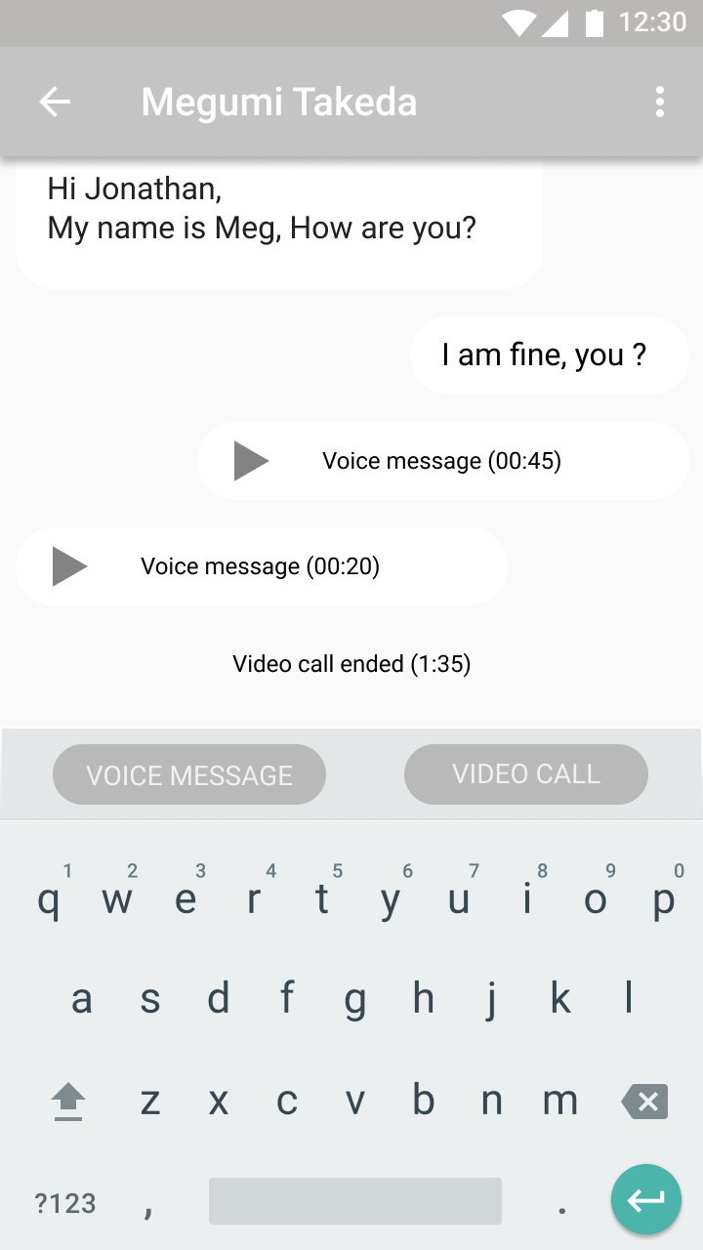 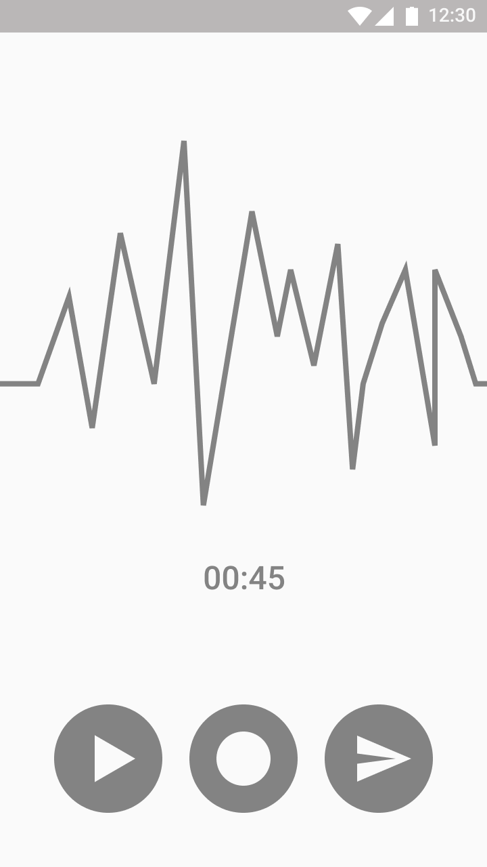

This messaging feature also provide a voice message function where users can share their voice message to their conversation partner to check the speaking mistake.

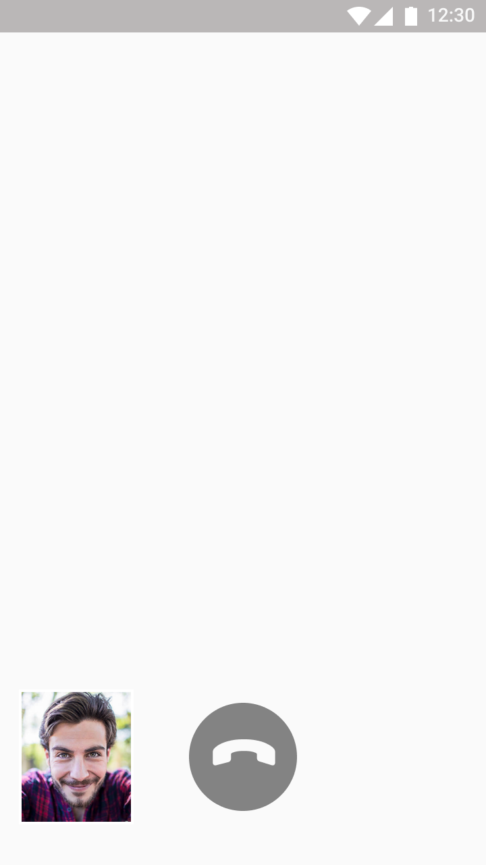

Lastly, the video call feature to support learners and tutors to communicate face to face and also boarden the learning method.